# DENYING INTERNET ACCESS FOR AZURE VM USING TERRAFORM

# Setup Terraform to Azure

provider "azurerm" {

features {}

}

# Created Resource Group

resource "azurerm_resource_group" "example" {

name = "example-resources01"

location = "West Europe"

}

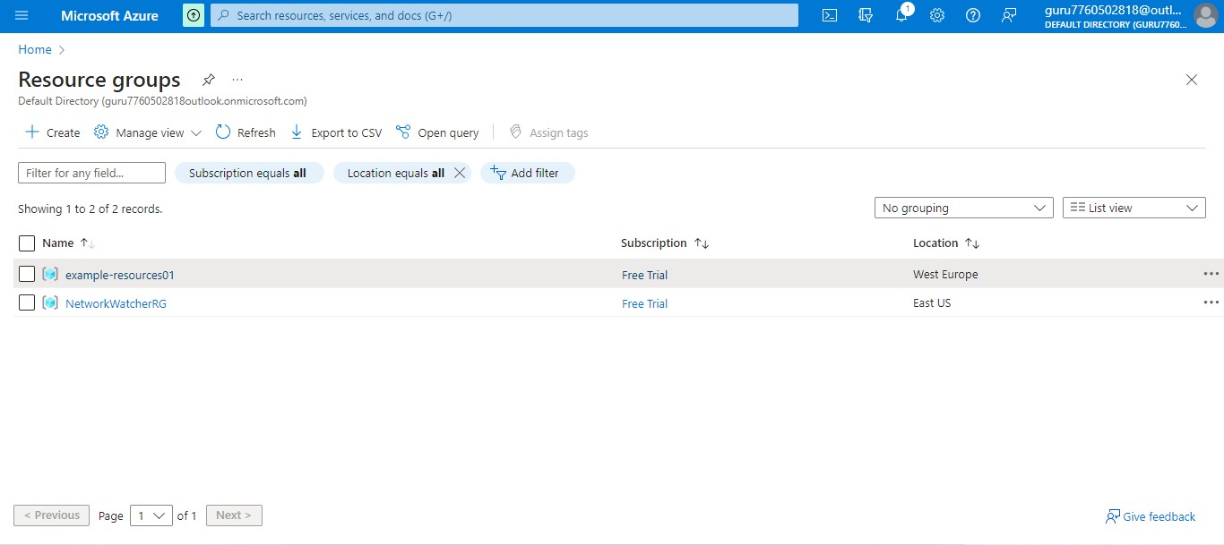

# Created Virtual Network

resource "azurerm_virtual_network" "example" {

name = "example-network"

address_space = ["10.0.0.0/16"]

location = azurerm_resource_group.example.location

resource_group_name = azurerm_resource_group.example.name

}

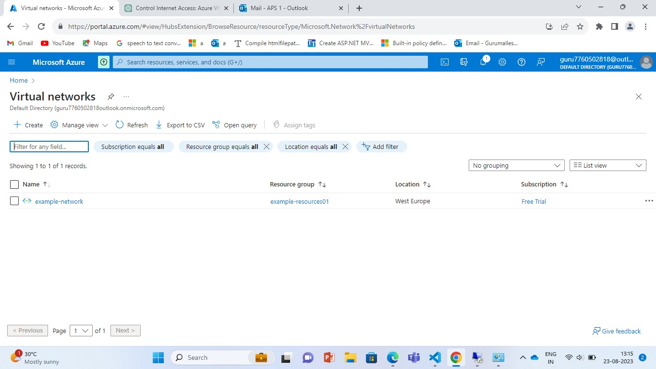

# Created subnet

resource "azurerm_subnet" "example" {

name = "internal"

resource_group_name = azurerm_resource_group.example.name

virtual_network_name = azurerm_virtual_network.example.name

address_prefixes = ["10.0.2.0/24"]

}

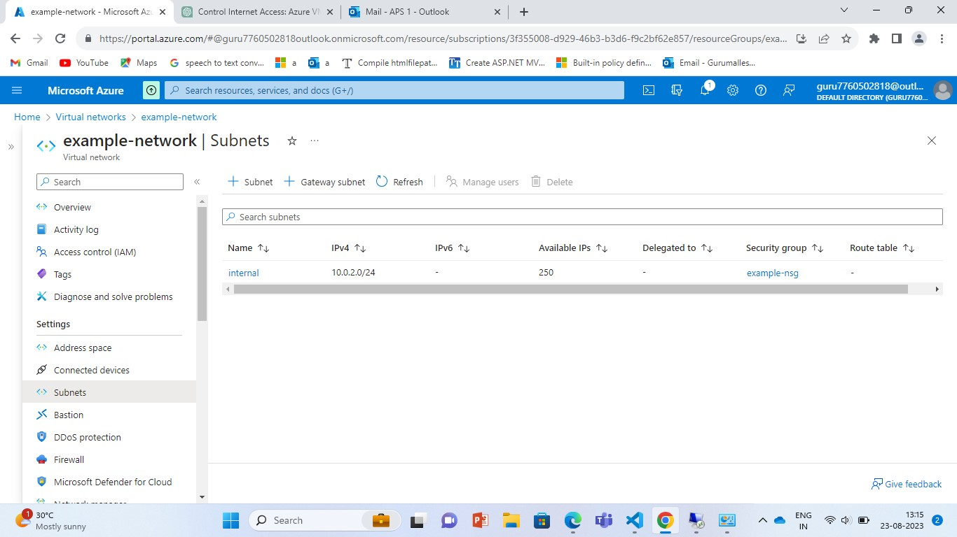

# Created Public IP

resource "azurerm_public_ip" "example" {

name = "example-publicip01"

location = azurerm_resource_group.example.location

resource_group_name = azurerm_resource_group.example.name

allocation_method = "Dynamic"

}

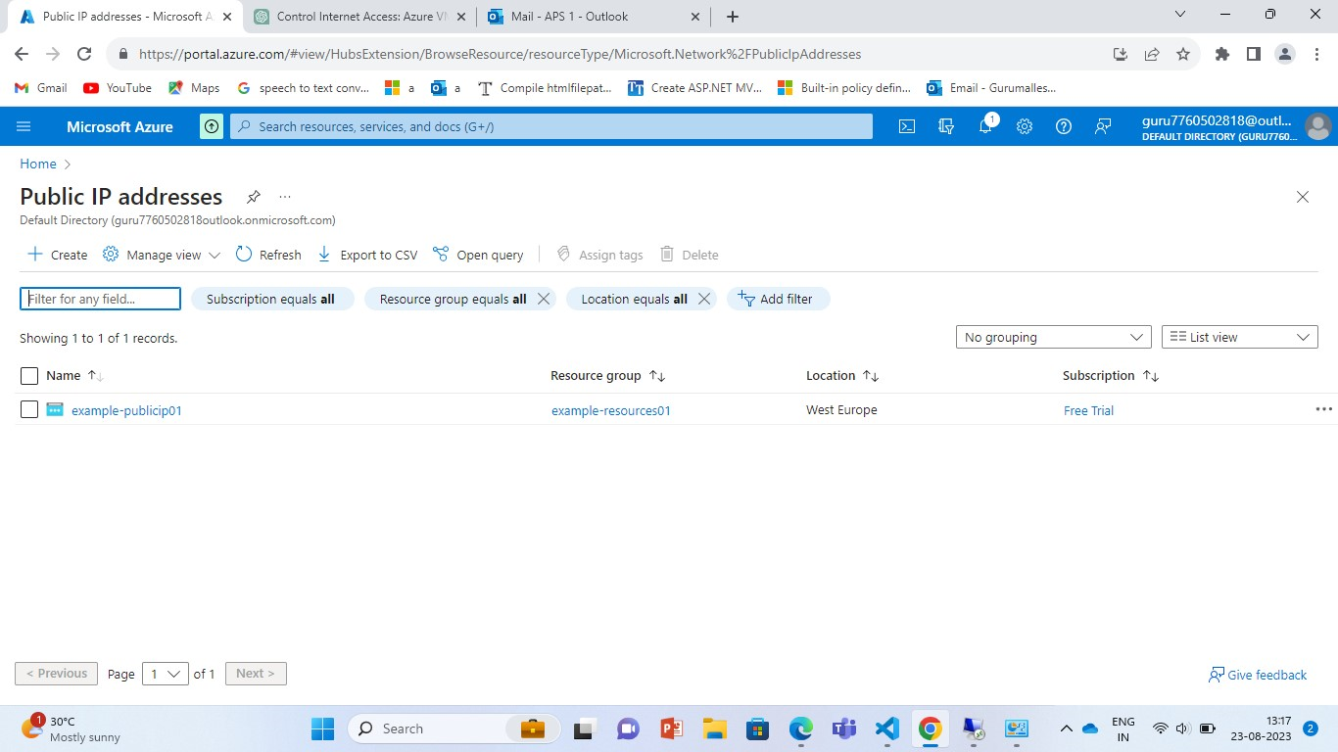

# Created Network Interface

resource "azurerm_network_interface" "example" {

name = "example-nic"

location = azurerm_resource_group.example.location

resource_group_name = azurerm_resource_group.example.name

ip_configuration {

name = "internal"

subnet_id = azurerm_subnet.example.id

private_ip_address_allocation = "Dynamic"

public_ip_address_id = azurerm_public_ip.example.id

}

}

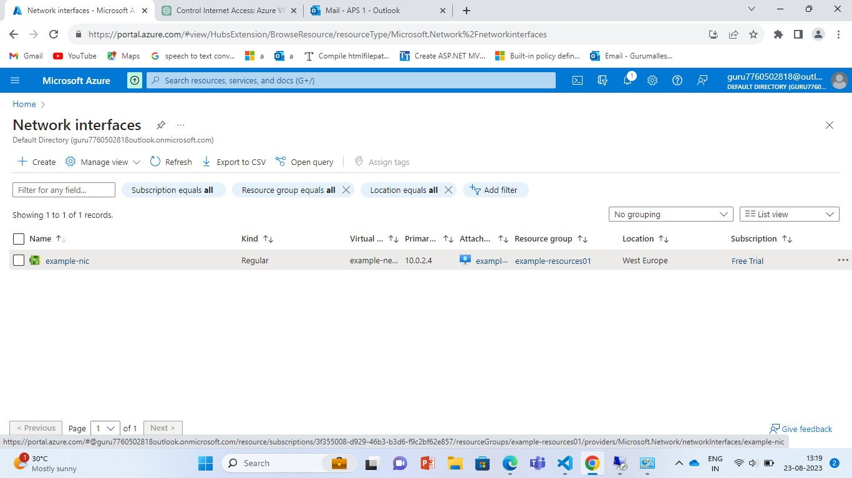

# Created Network security group

resource "azurerm_network_security_group" "example" {

name = "example-nsg"

location = azurerm_resource_group.example.location

resource_group_name = azurerm_resource_group.example.name

}

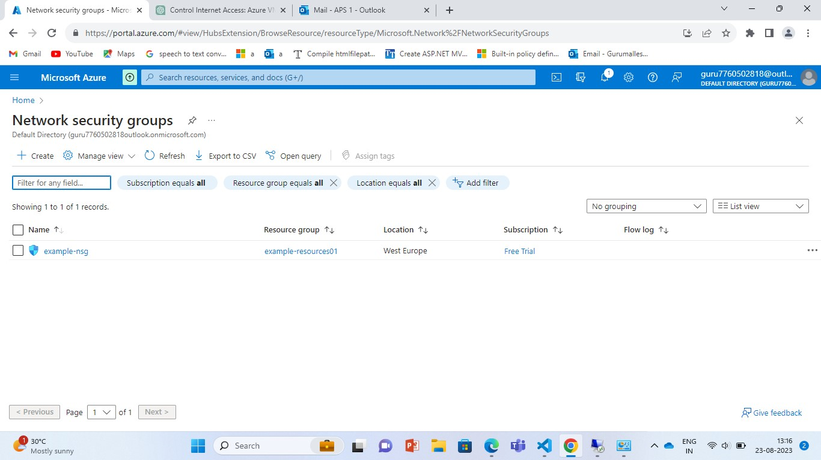

# Created Network security rule for denying internet for azure vm.

resource "azurerm_network_security_rule" "deny_outbound" {

name = "DenyAllInternet"

priority = 100

direction = "Outbound"

access = "Deny"

protocol = "*"

source_port_range = "*"

destination_port_range = "*"

source_address_prefix = "*"

destination_address_prefix = "*"

resource_group_name = azurerm_resource_group.example.name

network_security_group_name = azurerm_network_security_group.example.name

}

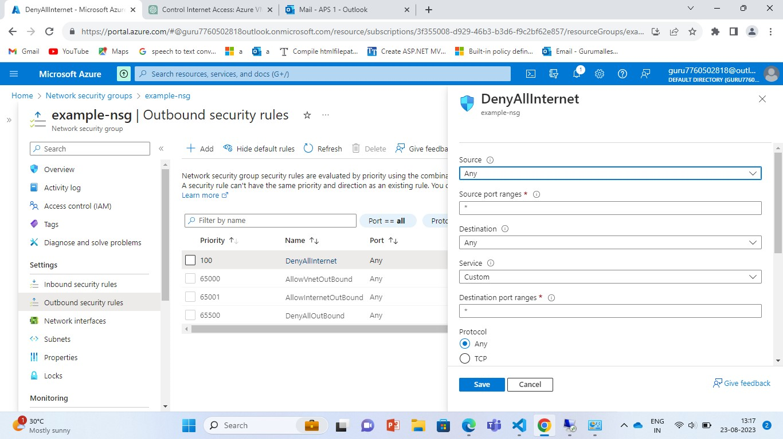

# Created Network security rule for allowing internet for azure vm

resource "azurerm_network_security_rule" "allow_rdp" {

name = "allow-rdp"

priority = 101

direction = "Inbound"

access = "Allow"

protocol = "Tcp"

source_port_range = "*"

destination_port_range = "3389"

source_address_prefix = "*"

destination_address_prefix = "*"

resource_group_name = azurerm_resource_group.example.name

network_security_group_name = azurerm_network_security_group.example.name

}

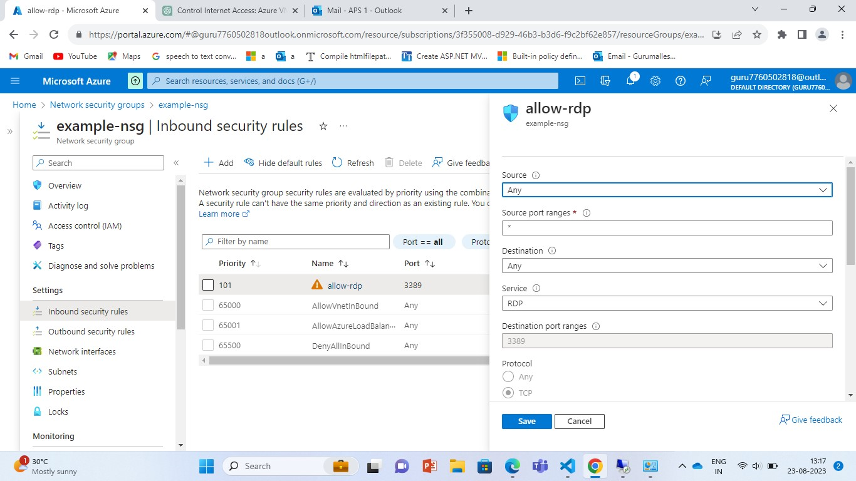

# Associating NSG to Subnet (only for one vm, for multiple vm associate to NIC)

resource "azurerm_subnet_network_security_group_association" "subnet" {

network_security_group_id = azurerm_network_security_group.example.id

subnet_id = azurerm_subnet.example.id

}

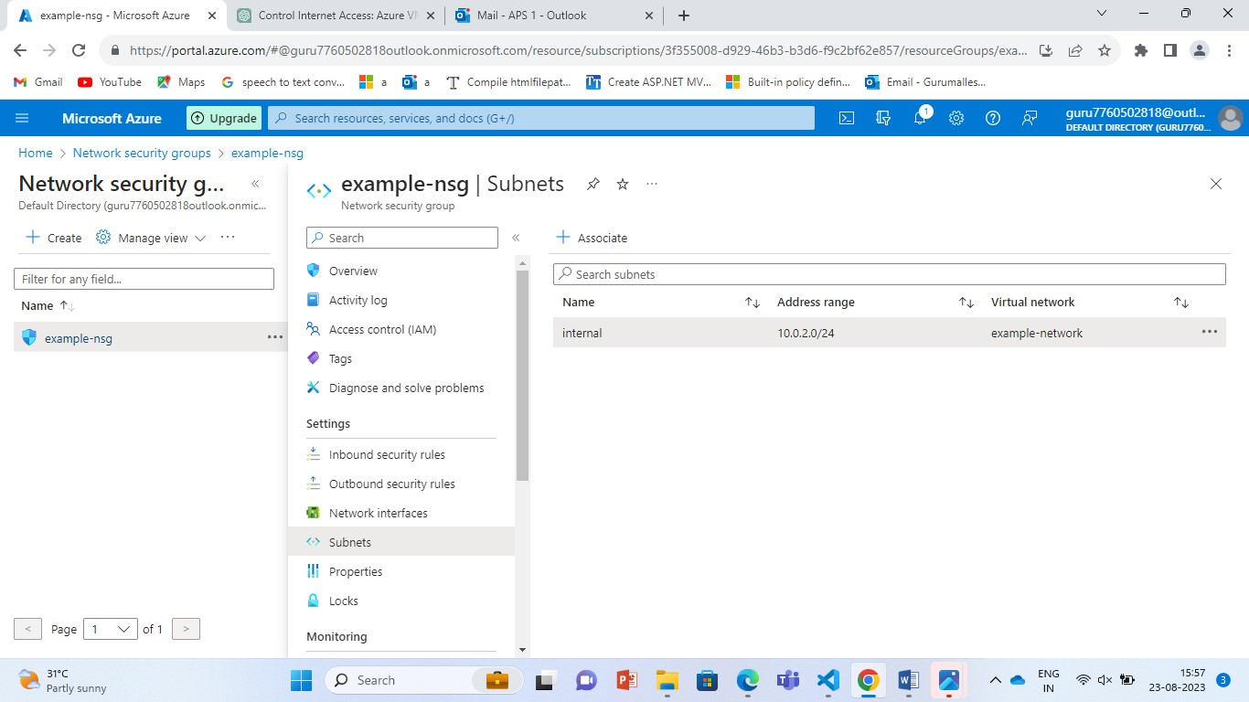

# Created Azure Windows Virtual machine

resource "azurerm_windows_virtual_machine" "example" {

name = "example-machine"

resource_group_name = azurerm_resource_group.example.name

location = azurerm_resource_group.example.location

size = "Standard_F2"

admin_username = "adminuser"

admin_password = "P@$$w0rd1234!"

network_interface_ids = [azurerm_network_interface.example.id,]

os_disk {

caching = "ReadWrite"

storage_account_type = "Standard_LRS"

}

source_image_reference {

publisher = "MicrosoftWindowsServer"

offer = "WindowsServer"

sku = "2016-Datacenter"

version = "latest"

}

}

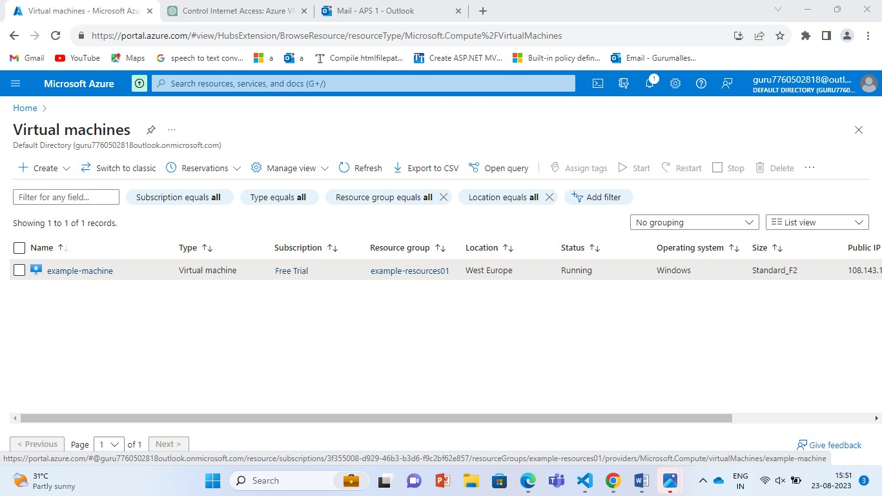

# For This VM Internet is denied

